……….
30723 Sodaville Rd Lebanon, Oregon
June 2020 Volume 6 Issue 20

City Hall (541) 258-8882 Mayor Suzie Hibbert email: sodaville@cityofsodaville.org
Web Address: www.sodaville.org Judy Smith – City Administrator
000000000000…………..000000000000000000000000000000

City Council Meeting City Hall Hours
7:00 pm June 18, 2020 Mon. – Thurs. 10 am – 2 pm
CITY UPDATE
The Budget Committee met on May 21, 2020 and approved a recommended 2020-2021 Budget to present for City Council approval on June 18. This is the Public Hearing Notice:

Notice of City of Sodaville

City of Sodaville Council​​​​​​​ Meeting and Public Hearings to Discuss Possible Uses of State Revenue Sharing Funds and the Fiscal Year 2020-2021 Budget

A public meeting of the City Council of the City of Sodaville, Linn County, State of Oregon, to discuss the budget for the fiscal year July 1, 2020 to June 30, 2021 will be held at Sodaville City Hall, 30723 Sodaville Road, on June 18, 2020 at 7:00 p.m. The purpose of this meeting is to introduce and review the City of Sodaville’s proposed budget.

A public hearing before the City of Sodaville Council to discuss possible uses of State Revenue Sharing Funds will be held at the June 18, 2020 meeting.

This is a public meeting where deliberation of the City of Sodaville Council will take place. Any person may appear at the meeting to discuss the proposed programs with the City of Sodaville Council. A copy of the budget document may be inspected on or after May 12, 2020 at City Hall, 30723 Sodaville Road, Monday - Thursday between 10:00 a.m. and 2:00 p.m.

City Hall is still on “lockdown” and I continue to work from home. It is business as usual with payments being credited to accounts, phone call messages and emails are being returned, and all other work being done. If you have any questions or concerns about anything, please don’t hesitate to call anytime.

Enjoy the June sunshine!
Judy Smith, City Administrator (cell: 541-905-2590)
MAYOR’S MESSAGE
Hello June 2020. What a month you have been already. COVID 19, now Riots?? Go Away June 2020.

I want to remind you if anyone feels unsafe in their homes that the City passed RESOLUTION NO. 18-09 A RESOLUTION STATING SUPPORT OF FEDERAL AND STATE CONSTITUTIONAL RIGHTS TO KEEP AND BEAR ARMS. Although, NO recreational shooting is allowed within the City limits.

I’m glad we are officially able to be outside and in the parks. Ours is wide open! Under Phase 2 guidelines, Recreational non-contact sports like tennis and pickleball will return to outdoor courts, and youth sports will have guidance regarding equipment sharing. Parents, be sure to explain to your children what that means.
Outdoor gatherings can have up to 100 people. This applies to pools, backyard weddings and recreational sports.

Since we are talking about the bad, let’s continue. When you are feeling the need to kill, weeds, please be aware of the proper dosage when mixing insecticides. The poison that’s killing your weeds is also harmful to those around you. Our honeybee population are not surviving the over spraying. I know of 5 Beehives that died last year and the only plausible cause for that many to have died would be them getting into heavily sprayed areas. The insecticides also filter into the ground which with rain, seep into the groundwater, and to follow the cycle, into our wells. Seems like a stretch, but, let’s not overuse the insecticides just in case.

Fun side! What have you done to celebrate that the kids’ Summer break is finally here and homeschooling is done for the summer? Have you been enjoying the fresh air and sunshine? What are you doing for Father’s Day? We are going to have a Dutchoven Gathering with our friends and families.

Take care Citizens, Please be Safe.
Mayor Suzie Hibbert

Public Works Newsletter
As most residents know last year was very dry and water had to be trucked in starting in July. This year the Spring rains are continuing into June which should help the water situation here in Sodaville for a while. However, last month’s meter readings and water sold showed a higher than normal usage for this time of year. In order to avoid purchasing and trucking water in from Lebanon please consider voluntary conservation during the Summer months. Many residents have started gardens as they do each year and that's ok. Try using alternate sources of water such as bath water or wash water to irrigate your gardens when possible. Go to the car wash in Lebanon to wash your car. The use of wells for non-potable use is allowed in Sodaville as long as the well is in no way connected to the City's water system. Consider contacting a water hauler for filling your pool if you have one.

The City of Sodaville will never let our customers run out of water so use what you need and consider the alternatives listed above to conserve where you can.

If you have other suggestions on how to save water please feel free to call me at 541-401-8537 or email me at sodavillepw@cityofsodaville.org.

Thank you and have a great Summer
Stan Smith, Public Works Director
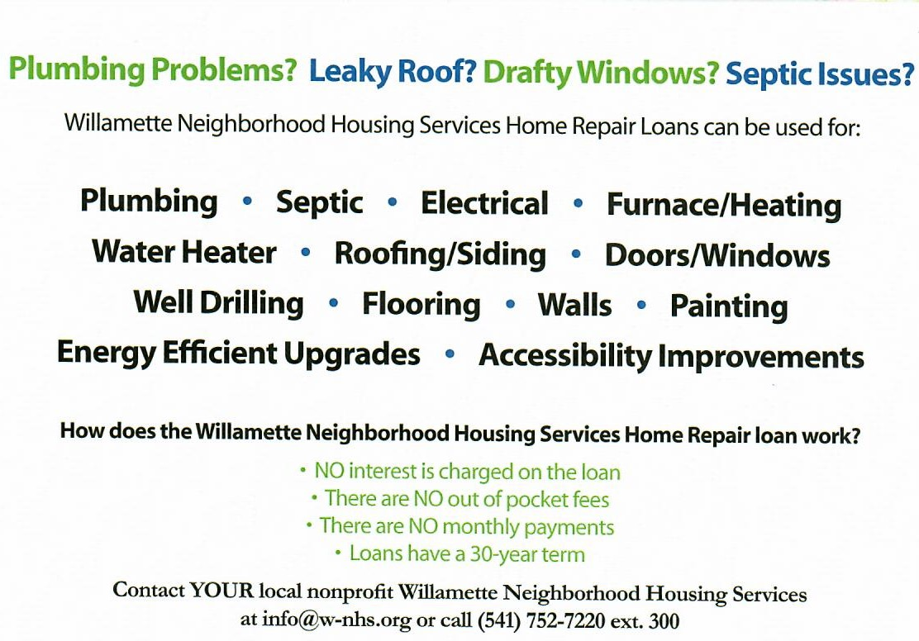

Country Girl Quilting
*Long-arm Machine Quilting
Call Sharon Hill and Joleana Altom at 541-401-7936
Carrie’s Country Inn Adult Foster Home
is located at 30785 Washington Street in Sodaville. “A safe, comfortable home
where you can keep your dignity, respect and independence.”
For information call: 541-570-1430
If you have any announcements, information or ads you wish to have published in the newsletter, please call
before the 6th of the month and I will be happy to insert them!
“The City of Sodaville is an equal opportunity provider and employer.”

