……….
30723 Sodaville Rd Lebanon, Oregon
December 2019 Volume 12 Issue 19

City Hall (541) 258-8882 Mayor Suzie Hibbert email: sodaville@cityofsodaville.org
Web Address: www.sodaville.org Judy Smith – City Administrator
000000000000…………..000000000000000000000000000000

City Council Meeting City Hall Hours
7:00 pm December 19, 2019 Mon. – Thurs. 10 am – 2 pm
CITY UPDATE
CITY OFFICES AND PUBLIC WORKS CLOSED DECEMBER 24, 25, 31, & JANUARY 1
There seems to be some confusion about tax dollars received by the City. Since tax statements have gone out over the last month or so, I would appreciate if you could look at it. You will notice that the City of Sodaville is only listed once and that amount is the only money paid to the City. The rate is .45 cents per thousand, meaning if your property is worth $100,000, you pay the city $45.00 a year. Average tax total received by the City is around $7,000 for the entire city. All other taxes listed are LFD, Aquatics Center, Linn County, Schools, etc. Work seen around the City, the park, streets, well improvements, etc. are all being done, or have been done with grant funds, not tax.
Sodaville History:
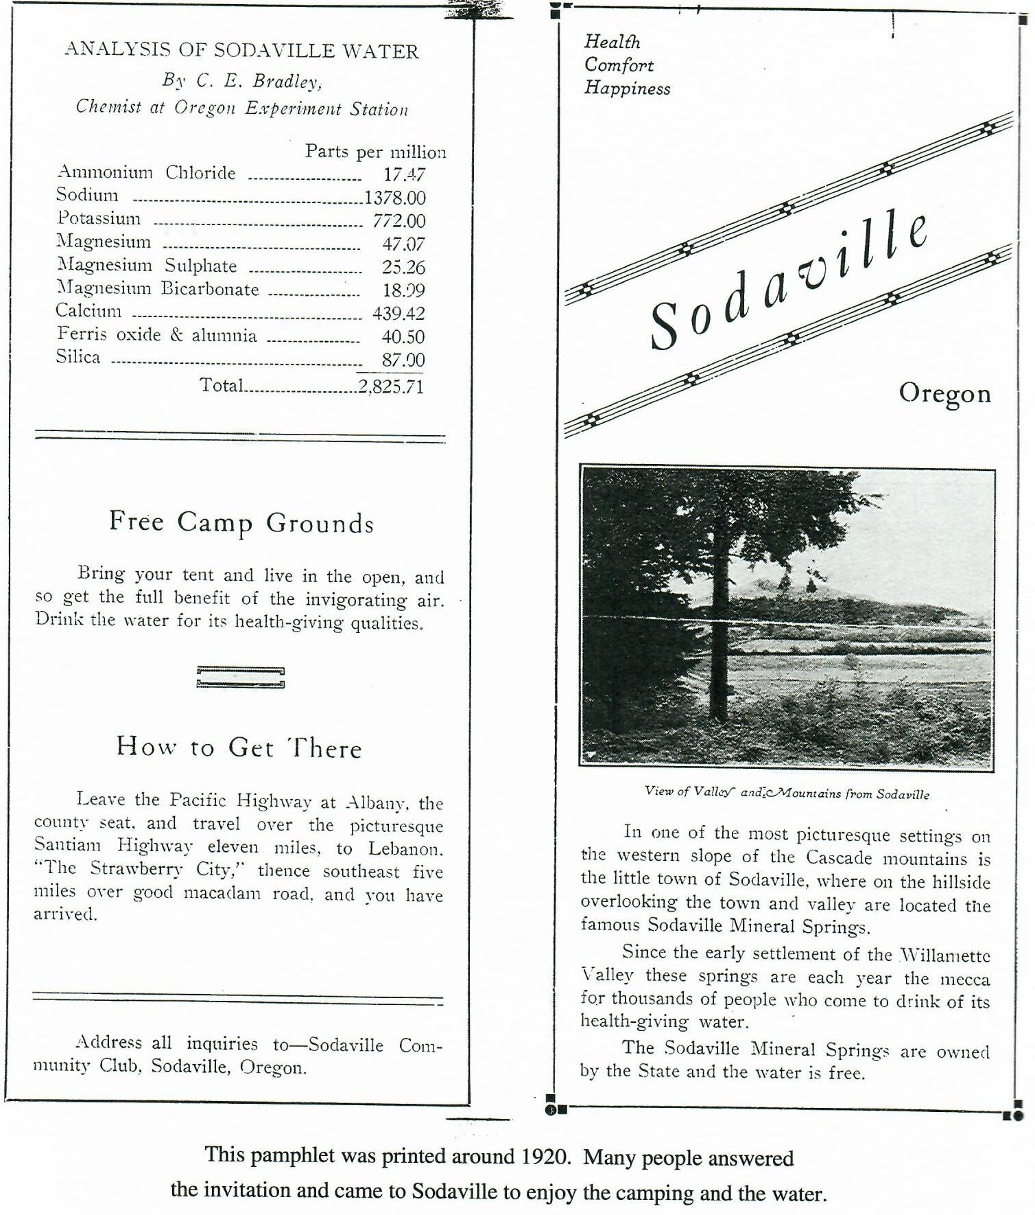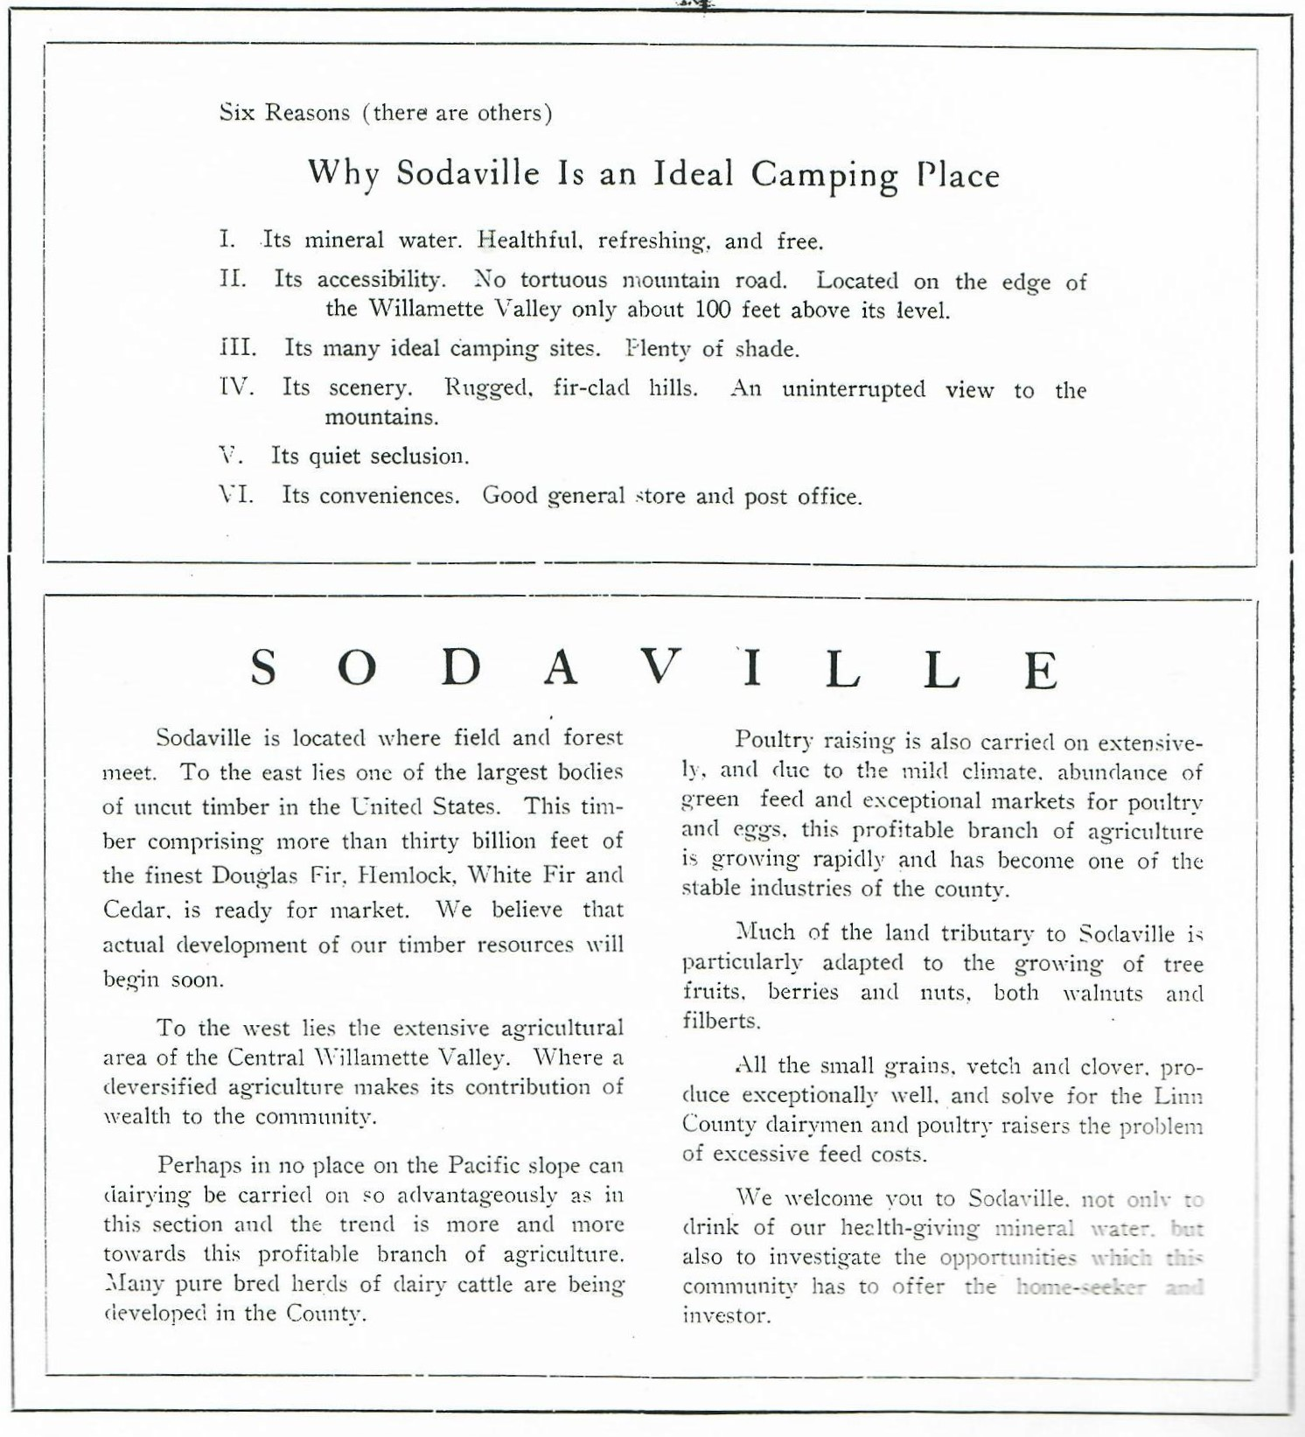
HAVE A WONDERFUL MERRY CHRISTMAS, HAPPY HANUKKAH, OR KWANZAA AND A VERY HAPPY NEW YEAR!!
Judy Smith, City Administrator
MAYOR’S MESSAGE
December! The best month of the year. Show Holiday cheer and be good to each other. Say Merry Christmas and remember why we even have a Christmas.

The Citizens Committee is lighting up the park. Councilor Morelos is giving his time to help decorate it for your viewing pleasure. Last year and the year before, some of the City’s decorations were stolen from the park. Let’s protect our City. If you see something illegal such as theft or destruction, please report it the Linn County Sheriff’s Office. Do not let a Grinch spoil your park.

We have completed to Grant Process for the Soda Springs Community Park😁 Thank you to all who helped. Actually, we had people from all around the area, some even drugged their visiting relatives (from California), along. We will be having a party this Spring to celebrate the completion of our new park. We are entertaining ideas of what to do with the old building. Be thinking, we’d love to hear your ideas.

We are STILL on water restrictions, please continue to conserve water. Yes, we are still working to provide water without having a 4-5 month shortage every year.

Merry Christmas Sodaville!!

Suzie mayorhibbert@gmail.com

Public Works Newsletter
On behalf of the City of Sodaville Public Works Department I would like to wish everyone a safe and joyful Merry Christmas and a Happy New Year.

The City's water situation is starting to change. For the first time since the City went on water restriction this year the reservoir is starting to fill on its own. Thank you all for watching your water use during these tough times. However, the City will remain on water restriction until the reservoir is full and there is enough confidence in the water system to allow additional use.

Cold weather is upon us. Make sure all your water pipes are insulated and your home is protected from the elements. Install foam blocks on your vents on your homes foundation to keep frigid winds from freezing pipes under your house. If you have a shut off for your outside hose bibs shut them off and drain the lines. Wrap exposed lines with insulation to keep them from freezing. Every year I am called out at least once for a leak that could have been avoided if the homeowner had just done these things. Leaks can be costly especially during water restriction so make sure you are protected from the elements.

Stan Smith, Public Works Director
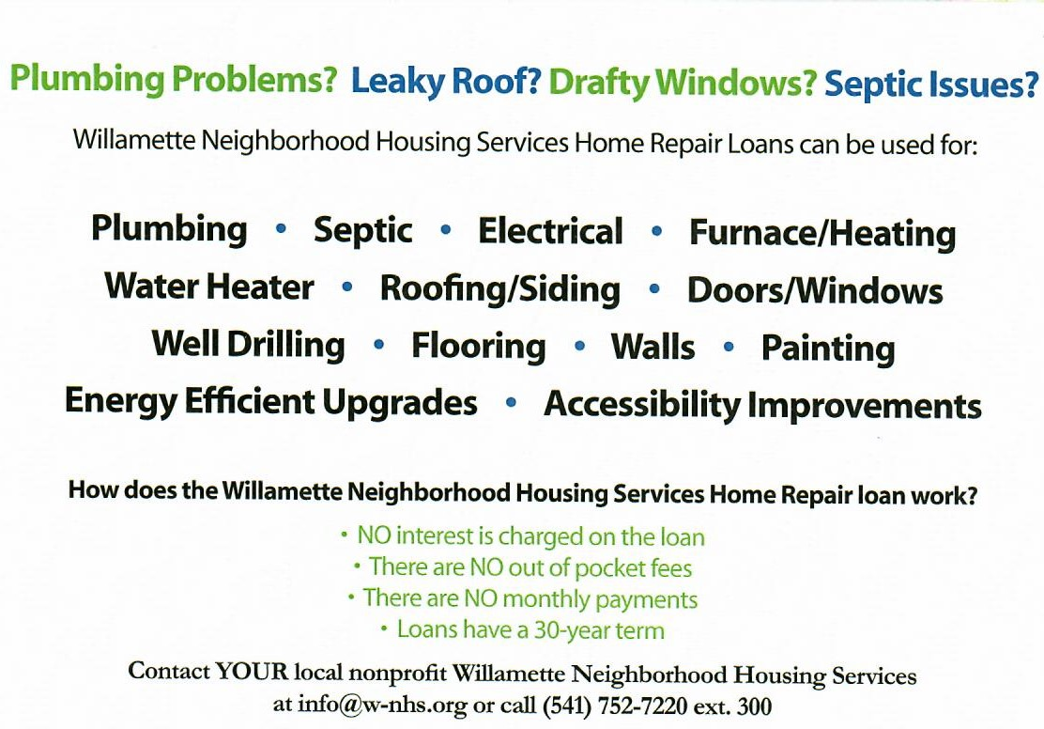
Country Girl Quilting
*Long-arm Machine Quilting
Call Sharon Hill and Joleana Altom at 541-401-7936
Carries Country Inn Adult Foster Home
is located at 30785 Washington Street in Sodaville. “A safe, comfortable home
where you can keep your dignity, respect and independence.”
For information call: 541-570-1430
If you have any announcements, information or ads you wish to have published in the newsletter, please call before the 6th of the month and I will be happy to insert them! “The City of Sodaville is an equal opportunity provider and employer.”

