……….
30723 Sodaville Rd Lebanon, Oregon
November 2019 Volume 11 Issue 19

City Hall (541) 258-8882 Mayor Suzie Hibbert email: sodaville@cityofsodaville.org
Web Address: www.sodaville.org Judy Smith – City Administrator
000000000000…………..000000000000000000000000000000

City Council Meeting City Hall Hours
7:00 pm November 21, 2019 Mon. – Thurs. 10 am – 2 pm

CITY UPDATE
CITY OFFICES AND PUBLIC WORKS CLOSED NOVEMBER 11, 27 & 28
The City has been contacted by ABC House regarding conducting a citizen training. ABC House offers trainings on topics of child safety including mandatory reporter training, recognizing, reporting and responding responsibly to child abuse (including child sexual abuse), keeping children/youth safe in the digital age, as well as a host of others. Additionally, they do presentations for youth leaders (babysitters or other youth in leadership roles) on child abuse and technology safety. Please let the city know if you would be interested in the training.

Just a reminder: if you place a water payment check in one of the boxes in the park, please put it in an envelope to protect it. The wet, rainy season is here and the checks tend to get damp.

Sodaville History:
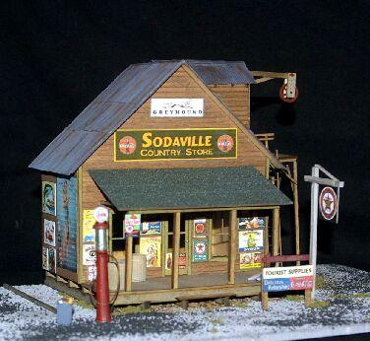
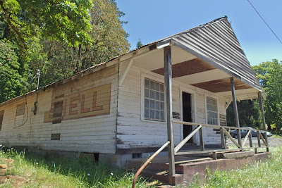
Not much is known about the old Sodaville Country Store located front and center in the Soda Springs Community Center Park. The Council is now having preliminary discussions as to what can and cannot be done with the building. It was the dream to create a new City Hall/Community Center using the building, but there are several issues. There is no footing under the foundation which means the building would have to be raised to fix that. Also, the Linn County Sanitarian has said that no septic system can be placed for use by the building meaning that there would be no restroom or kitchen facilities in the building. Since it would be deemed a Public Space, it would have to be retrofitted to meet current codes including earthquake. At the October 17 meeting, some ideas were discussed. This included removing siding to create a pavilion with or without a front façade, using it for storage, removing it and reclaiming the wood to build new, etc. The one thing agreed on was the wanting to preserve the Shell sign on the side. If you have any thoughts or ideas on what you would like to see happen with the old country store, please attend a meeting or contact City Hall! (The top picture is what it looks like now. The bottom picture is a HO Railroad piece depicting the old store).
Judy Smith, City Administrator
MAYOR’S MESSAGE
I love the colors of fall. November begins the season of Celebrations and honoring our Veterans is a great way to begin. My youngest son leaves for the Navy this month.

What are you thankful for? I’m thankful for many things, as far as the City goes, I’m thankful we have our hard working, dedicated employees and citizens. The Soda Springs Park project is officially finished! Wow, that was a lot of work!

The Citizen’s Planning Committee will be planning a celebration for the completion the park. The next event for the City to enjoy is Christmas lights. We are planning a day to put a light display in the park for Christmas. Possibly on December 7th @ 11am? Watch the website and Facebook page, The Buzz in Lebanon, Oregon.

Come find out more details @ 6:15pm, Nov 21, 2019.
City Council Meeting follows @ 7pm Nov 21, 2019
Please join in; we'd love to have you.

Take care and I’ll see you around,

Suzie mayorhibbert@gmail.com

Public Works Newsletter
Because of the long hot Summer and dryer than normal Fall the City's wells are still not producing enough water to sustain levels in the City's Reservoir. The wells have come back enough to reduce what the City is purchasing from Lebanon but not enough to lift the water restriction that has been in place since July of this year. As you may know the City's wells rely mostly on rainwater to recharge the aquifers feeding the wells. Once the rain begins several weeks of continued rain will be needed to saturate the ground and charge those aquifers feeding the wells. Thank you to everyone who made efforts to conserve during this year’s continuing water restriction.

I hope everyone is enjoying the new Soda Springs Community Center Park. It was a lot of work and brought many of us together for a common cause. For me it is great to see the kids playing on the playground that has been needed here for a long time. Here is a quick recap of the project. The Park Project was funded by the Oregon Parks and Recreation Department who receives Lottery Dollars from the State for these projects. City Administrator Judy Smith presented the project to the OPRD and received the grant. Mayor Suzie Hibbert spent hours and hours recruiting volunteers, working at the park, and keeping the paperwork in order. And finally the volunteers who showed up and gave up part of their weekends to help with this project and make it a success. You all deserve a huge round of applause.

Stan Smith, Public Works Director
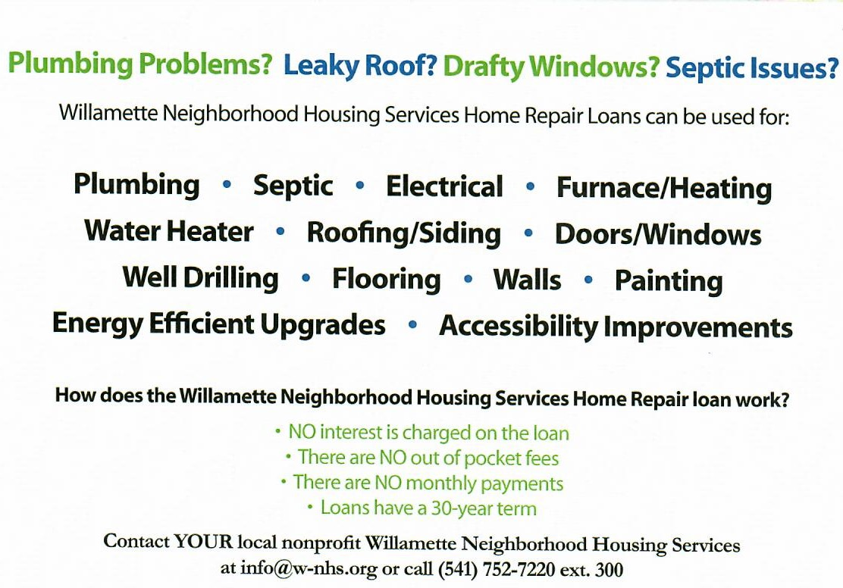
Country Girl Quilting
*Long-arm Machine Quilting
Call Sharon Hill and Joleana Altom at 541-401-7936
Carries Country Inn Adult Foster Home
is located at 30785 Washington Street in Sodaville. “A safe, comfortable home
where you can keep your dignity, respect and independence.”
For information call: 541-570-1430
If you have any announcements, information or ads you wish to have published in the newsletter, please call before the 6th of the month and I will be happy to insert them! “The City of Sodaville is an equal opportunity provider and employer.”

