……….
30723 Sodaville Rd Lebanon, Oregon
October 2018 Volume 10, Issue 18

City Hall (541) 258-8882 Mayor Suzie Hibbert email: sodaville@cityofsodaville.org
Web Address: www.sodaville.org Judy Smith – City Administrator
000000000000…………..000000000000000000000000000000

City Council Meeting City Hall Hours
7:00 pm October 18, 2018 Mon.–Thurs. 10 am–2 pm
CITY UPDATE
According to the National Integrated Drought Information System, 93 percent of the state is in a drought and 100 percent of the state is classified as abnormally dry. In the last 90 days, NIDIS reports, precipitation levels in western Oregon were the lowest they have been in 40 years. This situation is the cause for the low levels in the City’s 5 wells. The water is not coming into the aquifers and the City has had no option but to purchase water from the City of Lebanon and truck it to the reservoir. This would account for the “taste” of the water right now. The City of Lebanon does add chemicals to its water system whereas the City of Sodaville does have some of the best, pure water in the state and does not have to add any chemicals. The full funding for the Well #6 and 75,000 gallon reservoir project has been approved. A USDA grant of $370,525 and the Business Oregon grant funding for the almost 1 million dollar project will begin with a 72 hour test of the proposed well. Keller Associates engineering is currently finalizing the parameters of the project.

Also, the other 2 major projects in the City are moving ahead. Funding has been finalized with ODOT for a grant of $50,000 for the Vine Street Project. It should be starting in the next couple of months. Costs are being analyzed for the Soda Springs Community Center Park. The grant for that project is $225,000 from the Oregon Parks and Recreation Department. It has been quite the challenge to find contractors that are not extremely busy to give a quote on the project.

Judy Smith, City Administrator

MAYOR’S MESSAGE
October. October truly is the season change: Simply gorgeous, or simply wet. I’ll take it.

We are trucking in water now, and will until the rains start. The lower we keep the use, the lower the amount we will need to truck in. Check the house again for leaky faucets, it’s down to every drop you can save helps. Saves you money too.

Judy has been staying on top of the City’s comings and goings. Which includes the huge box of financial records she puts together to send to the Auditor. That has been delivered to the Auditor right on time.

Stan will cover the news on all the updates for the Vine St. Grant progress.

We are still in desperate need of contractors to complete the Soda Springs Park Project. We must get this done by October 2019. The grant then goes away. Free money does not hit the bank nor stay around if the work is not completed.

The Citizen’s Planning Committee has been working on the next event for the City, to enjoy; Christmas lights. The talk is lighting the park up for Christmas by getting sponsors for decorations. Or something like that. Come find out more details @ 6pm, Oct 18, 2018. The City Council Meeting follows @ 7pm Oct 18, 2018

Just for fun, my family now has a little library. “Maple On Alder” It’s also a Geocache.. Swing by Alder Street and read about it!

Come join in, see you there!
Suzie
mayorhibbert@gmail.com

Public Works Newsletter
As you all should know the City of Sodaville has gone on water restriction again this year. The City is currently supplementing its supply with water from the City of Lebanon. Lebanon currently draws its water from a shared canal with the City of Albany and is required to chlorinate its water. The addition of chlorinated water into a system that does not chlorinate can cause some issues. Usually the issues are brief and go away quickly. You can expect some discoloring or brownish water at times as the chlorine removes mineral deposits on the walls of the City's water mains. If you experience “dirty” water it is not dangerous to drink but is unpleasant to the eyes. Please flush each faucet in your home until the water runs clear. At least two weeks of steady rain is needed to start to replenish the aquifers that feed the City's wells. The City of Sodaville asks that you conserve as much as possible until the restriction is over.

The Vine Street Widening Project will be underway soon. The project will be reduced because of cost from twenty two feet wide to eighteen feet wide. It is expected that the widening will take place this year and paving will take place next spring. This is to give time for gravel to settle and compact before paving.

Stan Smith, Public Works Director

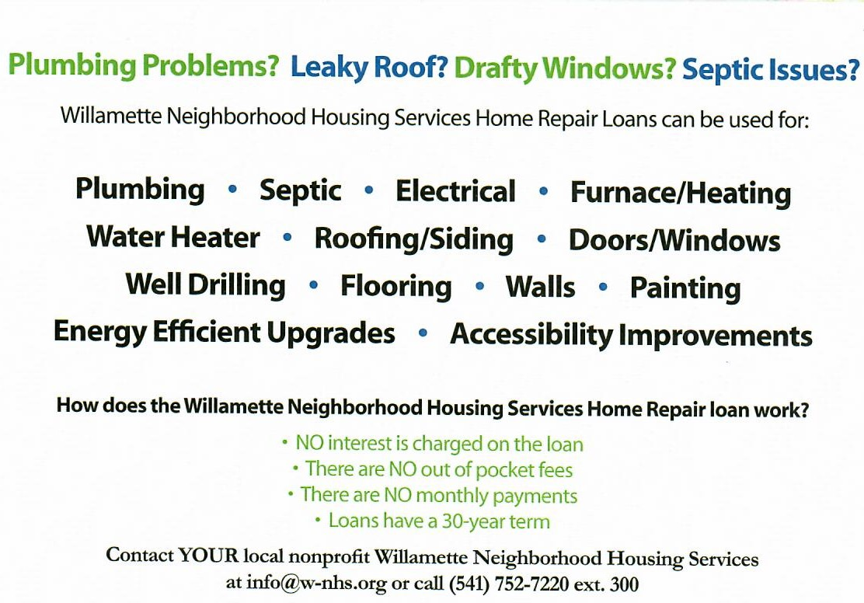

Country Girl Quilting
*Long-arm Machine Quilting
Call Sharon Hill and Joleana Altom at 541-401-7936
Carries Country Inn Adult Foster Home
is located at 30785 Washington Street in Sodaville.
“A safe, comfortable home where you can keep your
dignity, respect and independence.”
For information call: 541-570-1430

If you have any announcements, information or ads you wish to have published in the newsletter, please call before the 6th of the month and I will be happy to insert them!
“The City of Sodaville is an equal opportunity provider and employer.”

