……….
30723 Sodaville Rd Lebanon, Oregon
December 2017 Volume 12, Issue 17

City Hall (541) 258-8882 Mayor Suzie Hibbert email: sodaville@cityofsodaville.org
Web Address: www.sodaville.org Judy Smith – City Administrator
000000000000…………..000000000000000000000000000000

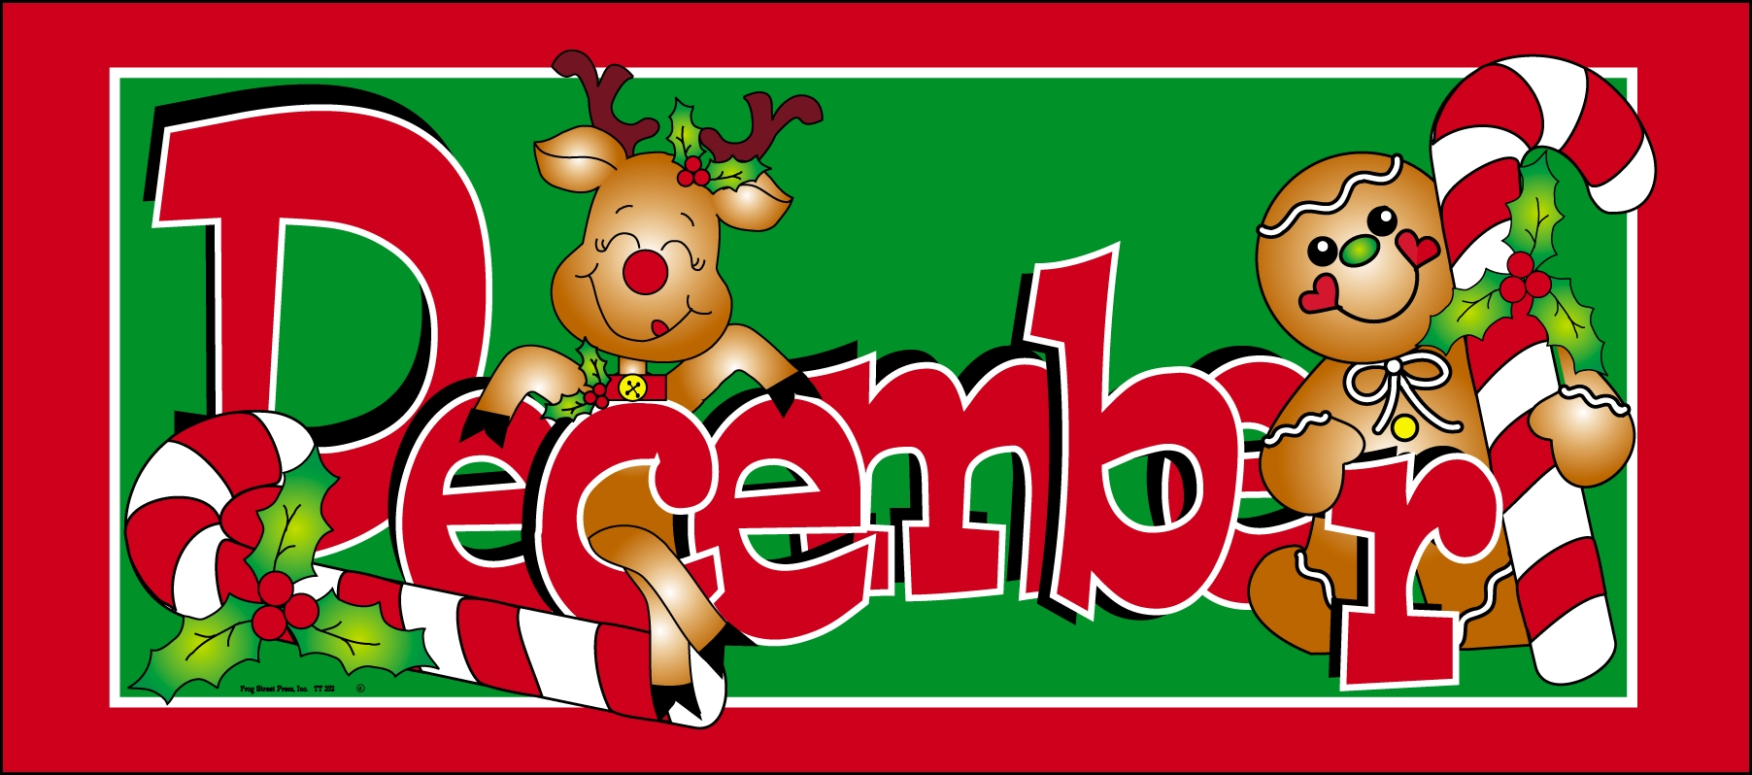
City Council Meeting City Hall Hours
7:00 pm December 21st 2017 Mon.–Thurs. 10 am–2 pm Christmas December 25
Hanukkah December 13 Kwanzaa December 26
CITY UPDATE

CITY HALL & PUBLIC WORKS WILL BE CLOSED Monday, DECEMBER 25TH, Tuesday December 26TH AND MONDAY JANUARY 1ST, 2018
With the holidays upon us, major projects are in slow down mode. With that being said, this is the time of year to catch up on ideas, paperwork, and planning for the coming year. 2018 will be a very busy time for the City of Sodaville. 2 major projects will be taking place. The first will be the creation of the Soda Springs Community Center Park with the $225,000 grant for the Oregon Parks and Recreation Department. The City would like as much input from the citizens on the project as possible. If you are interested in helping make decisions, or just giving thoughts or ideas on what you would like the park to look like, please contact City Hall.

The second project is of course the addition of Well #6 and an additional 75,000 gallon reservoir to the current Water System. Financing for the project with a cost of $937,000 is close to being fully in place. A grant from USDA for $370,000 and a loan of $196,800 at 1% for 30 years and a “forgiveness grant” of $370,200 from Business Oregon are the funds being used for the project. There are many parts to this project starting with securing the well with access, water rights, rehabilitating the existing well to municipal standards, engineering of piping, well house, electrical, and equipment needed to operate the well, not to mention the work of tapping into the existing system. This will be followed by adding the new reservoir to the Ridge Street water compound. I foresee lots of bids and contracts in 2018.

So my wish for the Holidays and the New Year is that the world takes a breath, stops the infighting and whining, and learns to work together. The past is the past, look forward to the future. “You have to accept whatever comes and the only important thing is that you meet it with courage and with the best that you have to give.” Eleanor Roosevelt

Merry Christmas and a very Happy New Year!!
Judy Smith, City Administrator
MAYOR’S MESSAGE
Merry Christmas Everyone ! I wish you Peace and Happiness this season.
2018 has many promises to keep and more to bring. New improvements to the Water system and to the new park! Although we the citizens have no creative say over the Water Improvements. We do have a creative say over the Soda Springs Park improvements. Be thinking what you would like to see. What style would you like? Bright and Colorful? Natural and Earthy? Somewhere in between? Be thinking, write it down, and come to the meetings which will get started again after the New Year. Any suggestions you give will be taken into consideration, however we receive it.

Remember to be prepared for cold nights, icy mornings and frozen pipes in between. Heat tape, water dripping overnight, only takes a little to keep the pipes from freezing. Keep your animals in a warm place with fresh warm water. I love the water buckets with the heat coil. Stay safe and warm!

Take Care and Enjoy the Season.
Mayor Suzie Hibbert mayorhibbert@gmail.com

Public Works Newsletter

Water Update
I am happy to report that the City’s reservoir is full and all wells are back on line and producing as they normally would. The City of Sodaville did not have to purchase and truck in water this year mainly because of the amount of rain that fell last fall. Couple that with the 5 wells’ rehabilitations and conservation efforts by all of you and we made it through the year.

It’s getting cold outside!! During a freezing weather event it is important to keep a few things in mind.

Protecting Your Pipes
- Disconnect your hoses and cover your hose bibs with a Styrofoam cover that fits snuggly again your house. If your hose bibs have a shut-off in the garage or under the house then shut them off and open the hose bib to let the water drain out.
- Insulate any exposed pipes with pipe wrap or Styrofoam pipe covers. They are available at most any Hardware store.
- Leave all your faucets in the house dripping during extreme cold conditions especially during evening hours when it is coldest and water is not being used regularly. The City’s groundwater supply is generally 45 to 55 degrees. If water sits in exposed pipes without moving for too long the temperature will drop and possibly freeze.
- Cover the vents in your foundation. During the summer months you need the airflow under your house. During the winter the open vents allow cold air to reach water pipes under the house, which may cause them to freeze.

Driving
- If you must drive make sure your vehicle is equipped to handle snow or ice (studded tires, chains, 4X4).
- Keep a supply of water and extra blankets in your car in case your vehicle becomes disabled. It may be some time before help arrives.
- Avoid side streets as much as possible. Side streets are usually not maintained where well-traveled streets have chemical deicers and are plowed. (The main streets in the City are maintained by Linn County)
- Most importantly take your time. Getting to your destination safely is the goal.

The holiday season is upon us and the City of Sodaville Public Works Department would like to wish you all a safe Merry Christmas and a Happy New Year.
Stan Smith, Public Works Director
Condolences go out to the family of Stan Taylor. He was a longtime resident that served on City Council many years ago and was very active in several Community projects.

Country Girl Quilting
*Long-arm Machine Quilting

Call Sharon Hill and Joleana Altom at 541-401-7936
Carries Country Inn Adult Foster Home

is located at 30785 Washington Street in Sodaville.
“A safe, comfortable home where you can keep your
dignity, respect and independence.”
ha
For information call: 541-570-1430

If you have any announcements, information or ads you wish to have published in the newsletter, please call before the 6th of the month and I will be happy to insert them!
“The City of Sodaville is an equal opportunity provider and employer.”

